- Environment Preparation and KServe Installation
Install and configure KServe on a local Kubernetes cluster (Minikube)
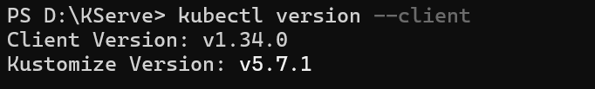
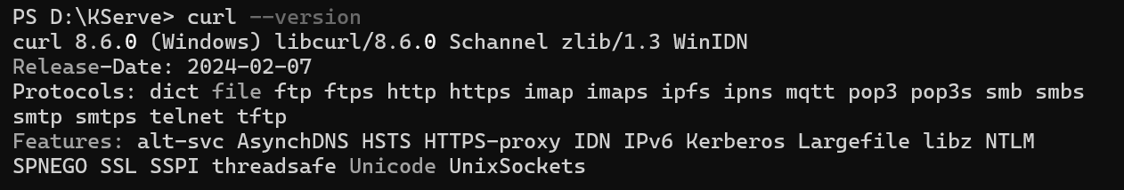

Using Minikube:
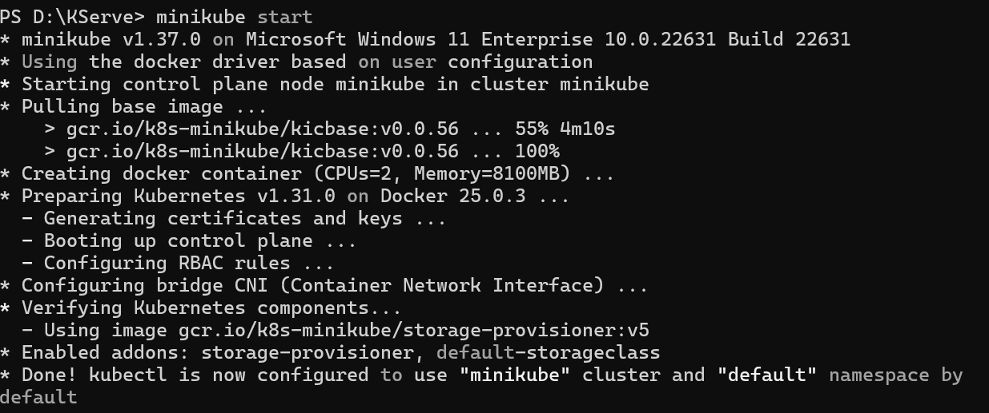

Install all dependencies, KServe (Standard), and LLMInferenceService:
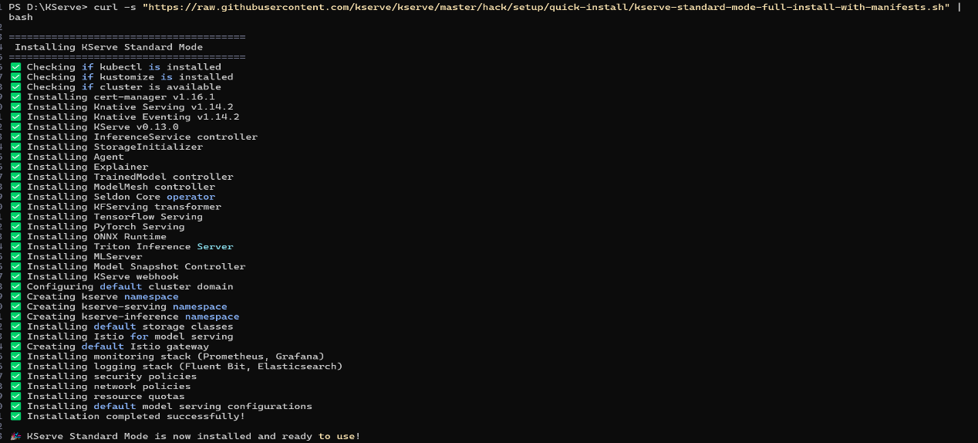

verify all components are working:
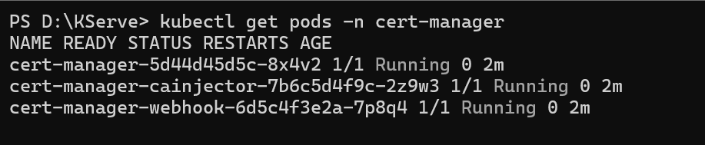

Deploy a predictive model using a KServe InferenceService、

Create an InferenceService
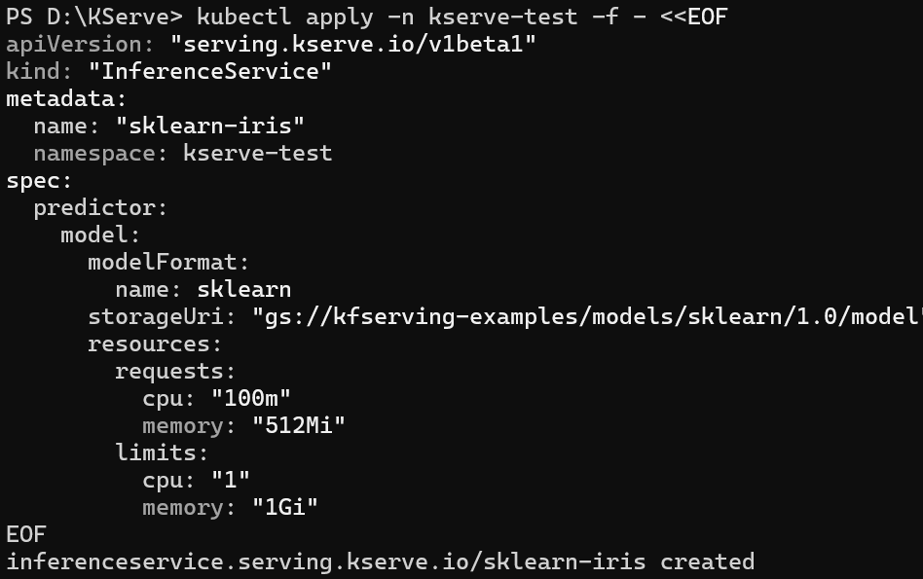

Check InferenceService status

Determine the ingress IP and ports

Use an external load balancer to ingress gateway

Perform inference
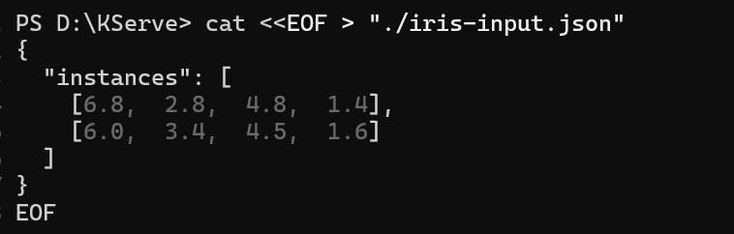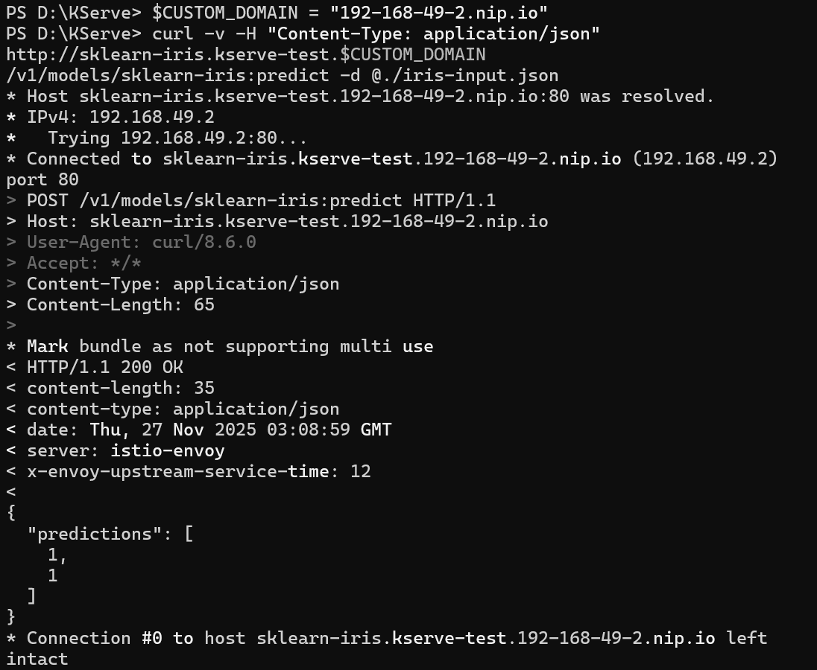
see two predictions returned (i.e. {"predictions": [1, 1]}). Both sets of data points sent for inference correspond to the flower with index 1. In this case, the model predicts that both flowers are "Iris Versicolour".

